**Functionality and Requirements specifications:**

1. When starting the application, user will be presented with a splash screen giving them the option to login, register an account, recover password of an existing account, or exit the program.
2. Log In will require a username and password that will be validated against a database.
3. Registration accepts the following information and will be stored into the database:
   * 1. first name
     2. last name
     3. address
     4. zip, state
     5. username
     6. password
     7. Email
     8. SSN
     9. security question
     10. and an answer for the security question
4. User can login using username and password if it is properly validated by the database information.
5. Recovering password will require existing username that will be validated by the database.
6. If username is validated by database, it will display the security question for the user and a field to enter the answer to the security question.
7. If the security question answer entered is correct, an alert box displaying the password for the account will be displayed.
8. Users can be distinguished between customer and admin. Users will be registered as a customer by default.
9. Once logged in to the main page all flights booked by a user will be displayed on the main page
10. User can enter flight number from their list of booked flights and delete them from their account from their main page.
11. User can refresh their booked flights.
12. Users can click on a search flights button from the main page to take them to a search page.
13. From the search page users can enter search term into a text field and sort by search categories. results will be displayed in listview.
14. Users can book a flight by entering flight number they would like to book into the add flight textbox and clicking the add flight button.
15. If a user has already booked the selected flight or the flight time conflicts with already booked flight, user will be notified accordingly via alert box.
16. if the user is an admin, their main page will have the option to go to an add fight page, or an edit/delete page.
17. On the add flight page, admin can enter flight details into the text box, and click a create flight button to create the flight.
18. If the departure date and time is set to after the arrival date and time, it will warn the user of a conflict and will not let them create the flight.
19. The edit delete flight page will have a drop down option to update or delete a fligt based on flight number.
20. If the update option is selected, admin can select the category to update and enter the updated information..
21. User must click submit to delete or edit flight.
22. All pages must have an option to return to the main page.
23. The user can log out from the main page.

**Class UML Diagrams:**

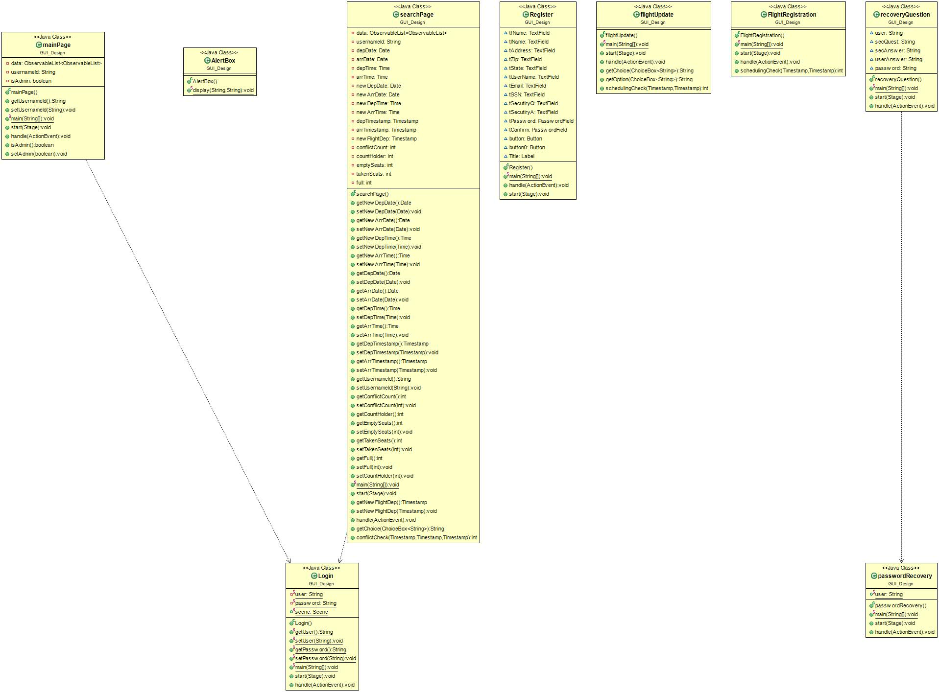

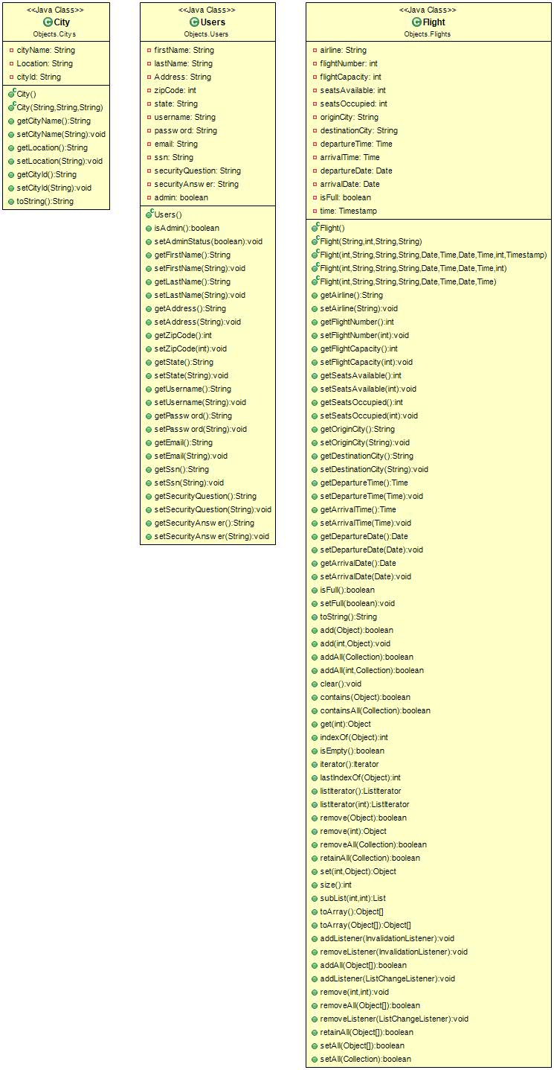

**Database Model:**

